The way a course looks online is important and may be responsible for increasing or reducing online stress both for learners and teachers. Moodle offers the possibility of different ways of presenting your courses and as online course content builds up, we have been experimenting with ways of avoiding the scroll of death (having to scroll down for ages to find content). When online learning and/or teaching it is too easy for your attention to become completely riveted on your computer, with tunnel vision kicking in. Adding images that do not have anything to do with course content may at first glance seem to be counter-intuitive and to present multimodal/coherence problems. However, the idea is to introduce different sensory reactions, to ‘open’ the mind - the virtual equivalent of going for a walk.

Examples of Moodle Course Presentations
- Course Image
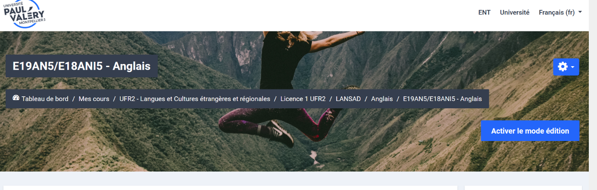
Weekly presentation
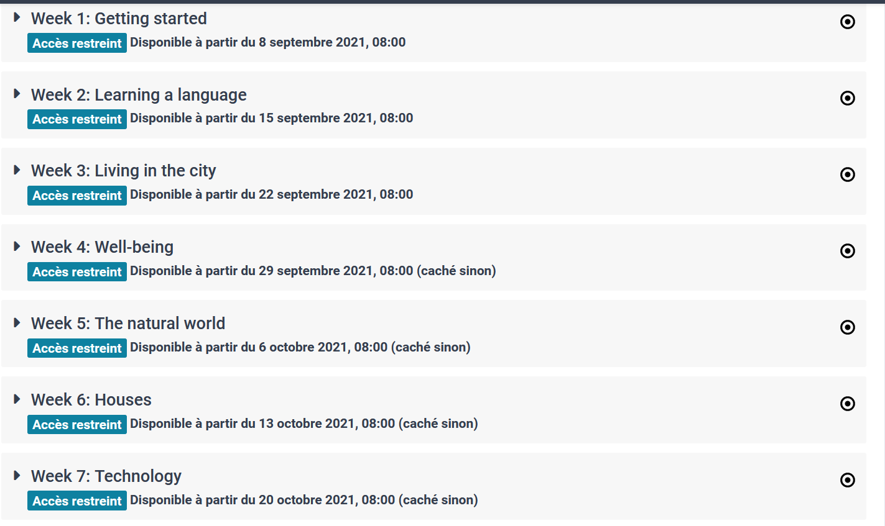
- Course Image and theme (skies in the Cévennes)
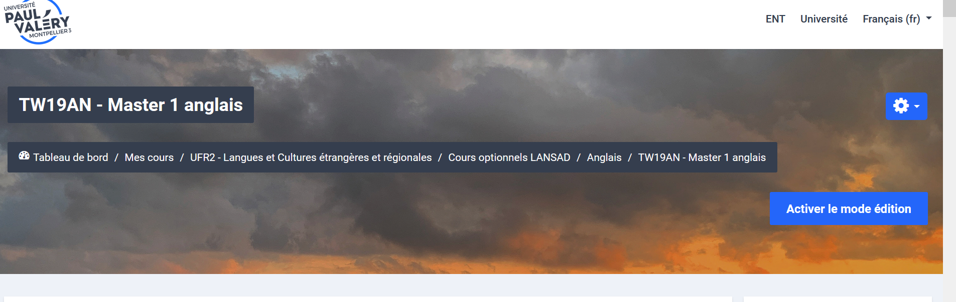

Weekly Presentation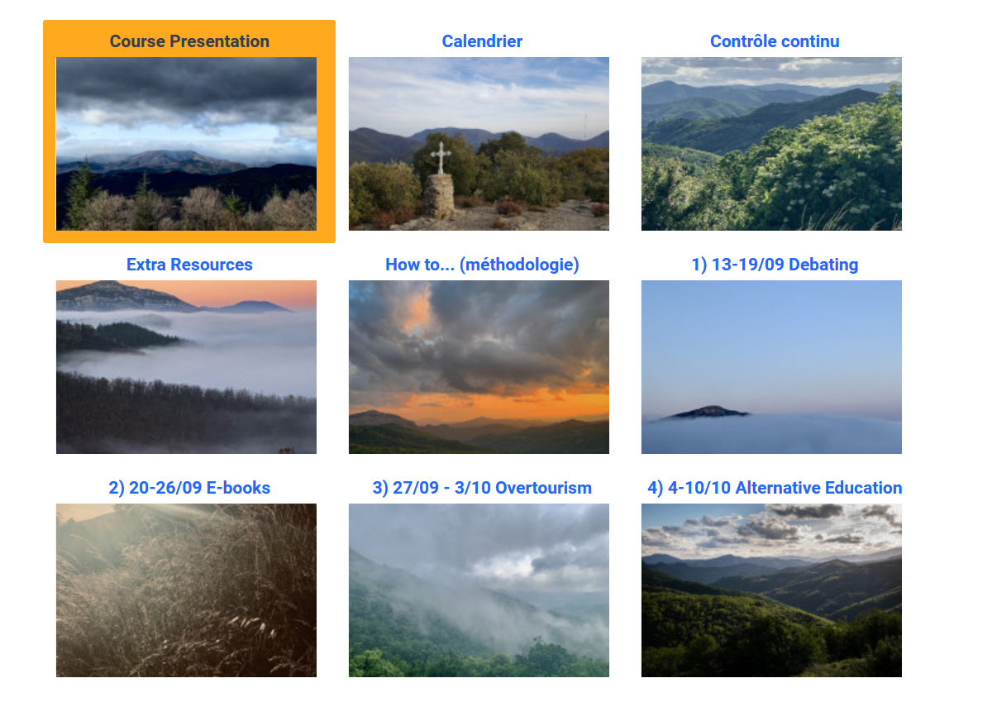
- Course Image and Theme (Student Images – interpretation of Kerouac’s “On the Road’ by Allison Guiraud (2018).
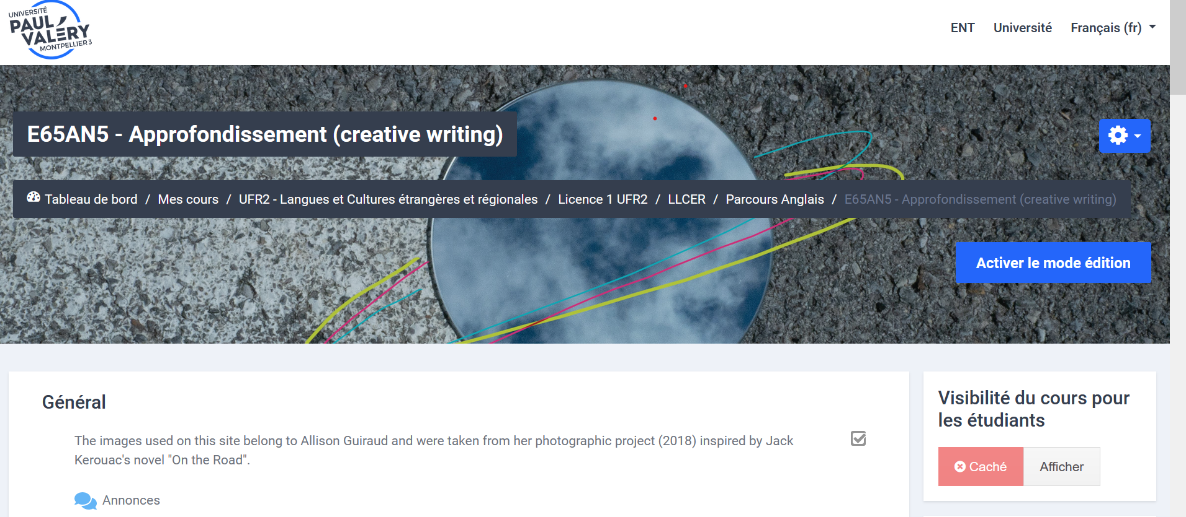

Weekly Presentation
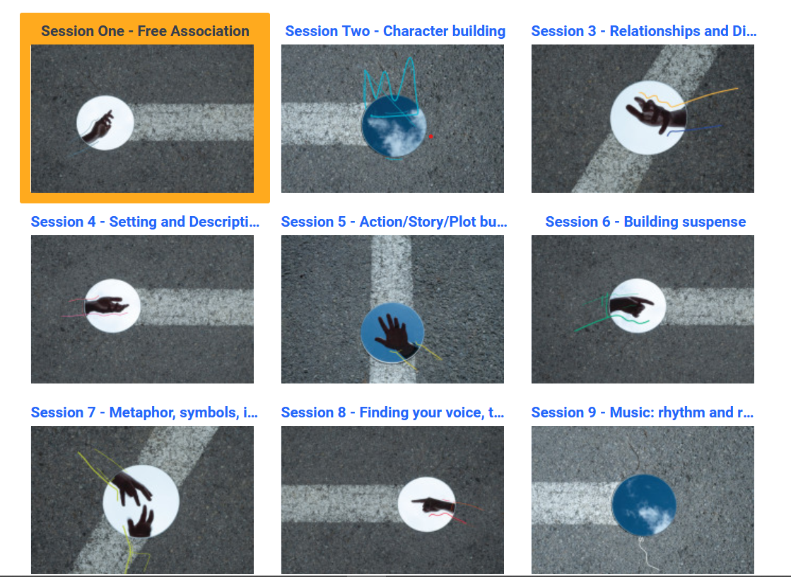
To Modify Course Image (for all 3 examples):
Paramètres
Modifier les paramètres du cours
Image de cours
- Télécharger votre image

To Modify Course Presentation (Example 1):
Paramètres
Modifier les paramètres du cours
Format de cours
- Sections réduites
- Sections cachées invisibles
Examples 2 and 3 :
Modifier les paramètres du cours
Format de cours

Format de cours
- Vue en image (exemples 2 et 3)
- Sections cachées affichées sous forme repliée
- Afficher toutes les sections sur une même page

